April 1, 2020

Donald J. Trump

The President

The White House

Washington, DC 20500

Mr. President:

We write in support of Governor Kate Brown’s request to mobilize up to 1,250 members of the Oregon National Guard in a Title 32 USC 502(f) status. Your swift approval of the governor’s request will help the governor and her team respond to the ongoing COVID-19 pandemic.

The rapid spread of COVID-19 has caused massive disruption to American life, shuttering schools and closing businesses on an unprecedented scale.  Governor Brown fully activated Oregon’s Emergency Coordination Center in early March and has since ordered Oregonians to stay home and non-essential businesses to cease operations.  The state is reporting more than 650 confirmed cases of COVID-19 and 18 deaths as of this writing—numbers that grow by the day.

Oregon is a resilient and forward-thinking state and Oregon National Guardsmen have already been working to set up mobile hospitals and tents. But no state will be able to respond to the COVID-19 pandemic alone, which is why Governor Brown has requested Title 32 authority and funding. If approved, this request would permit her to deploy the Oregon Guard in multiple capacities to meet immediate COVID-19 response needs across the state.

We thank you in advance for your expedited review of this request and look forward to working with you to support the response effort in Oregon and across the country.

 Sincerely,



Ron Wyden Jeffrey A. Merkley

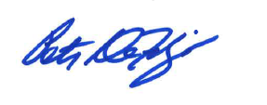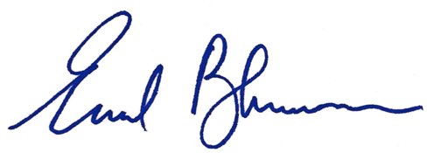 United States Senator United States Senator

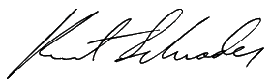

Earl Blumenauer Peter DeFazio Kurt Schrader

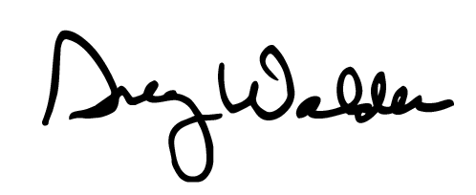 Member of Congress Member of Congress Member of Congress

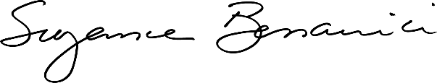

Suzanne Bonamici Greg Walden

Member of Congress Member of Congress